Small Parish Development Grant
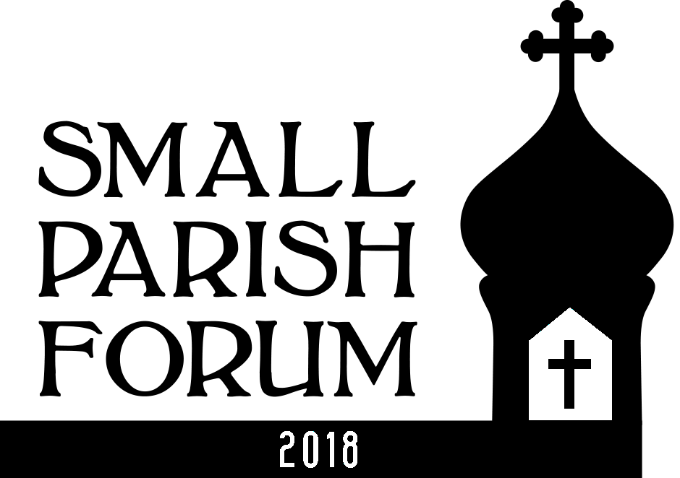

Small Parish Forum

Orthodox Church in America

Archdiocese of Western Pennsylvania Diocese of Midwest Bulgarian Diocese

Background Information for Applicants

Background

Overview
The Small Parish Development Grant initiative is an experimental activity of the Small Parish Forum. It is designed to stimulate parishes to begin new ministries or further develop existing parish ministries.
One, or possibly two, cash grants of approximately $2000 will be provided to a small parish (or parishes if two are awarded) as an incentive to begin internal and external efforts oriented to strengthen their parish.
Most parishes have an idea or three --something that the priest or the parish council or a collection of parishioners have discussed but they never quite pulled together. Perhaps lack of funds was a barrier. Perhaps encouragement was needed. Some parishes assuming “we could never do that” even lack a good set of ideas. It is hoped that the Small Parish Development Grant can, at least in small part, begin to overcome these barriers.
This initiative can work in the following ways to help breathe life into parishes:
- Incentivized by the prospect of even a modest grant and buoyed by attendance at the Small Parish Forum, a parish begins a conversation on “what we can do to become a more vibrant parish – to get ‘unstuck’”.
- Parishes receiving grants will be required to take action – they will begin to “turn the crank” on otherwise static parish situations.
- Some parishes not receiving grants may become inspired to enact their project anyway -- using internal or parishioner funds.
- Feedback -- “lessons learned” harvested from parishes receiving grants -- can be used to stimulate new efforts in other parishes that heretofore decided to watch from the sidelines.

Grant Process

Deadline: October 15, 2018
Grants will be decided upon by the Small Parish Forum planning team. Applications are due October 15, 2018. The planning team will announce its decision in early October.

Qualifications of Applicant Parishes
Grants are given to parishes not persons.
The parish must have attended the Small Parish Forum.

Administration of the Grant Program
Parishes receiving grants will be expected to provide interim reports as requested. This will be defined at the time of the award. We will expect you to return to next year’s Forum to share what worked and what didn’t.
Payment terms (lump sum, quarterly, etc.) will be discussed after selection.
Grants are to be used for ministry activities that are or will become part of parish life. A parish can be starting something new or strengthening something already in existence. The new activities/ministries that are the object of the grant can fall into various parish areas -- charitable outreach, adult education, worship, evangelization, campus outreach. No legitimate area of healthy, vibrant parish life is, per se, out of bounds for consideration.
Parishes are required to do real ‘work ’as part of the grant. The grants are not simply cash awards to support struggling parishes. The grants provide financial incentive to stimulate action and effort on the part of parishes that desire to begin a cycle of renewed vibrancy.
If the grant project includes actual out of pocket costs the grant money may, of course be used to underwrite actual costs associated with beginning and operating the ministry.
Proposals for projects which involve effort on the part of the parish, but do not have direct costs attached are also acceptable. In the case of projects without direct costs the grant monies can be used to support other parts of the parish budget. Grant projects which incur direct costs are more likely to be funded than those involving effort only.
Grants will not be made for facilities improvements.

Grant Criteria
The following are the criteria used for selecting grants:
Impact
What is the probable impact of the grant on the parish? Does it address a key issue or need of the parish? Does the proposed action shore up a weakness or build upon a strength?
Breadth of Involvement
Does this grant engage a broad cross section of the parish or mission? Will this be undertaken by 2-3 persons leaving the remainder of the parish oblivious to the effort?
Probability of effective execution
Effectiveness of your plan. Convince reviewers that you can and will do what you say you will do and, having done what you’ve said, that there is a reasonable possibility of a desirable outcome.
Parish Need
Parishes with abundant resources will have a lower probability of receiving an award than parishes that are in difficult financial condition. Nonetheless, strong, financially healthy parishes are not exempt. This is one criterion among many.

Transferability/ Pass it forward
Applicability of results to other parishes. Ideas/proposals that offer a chance to export learning to other parishes will be viewed as desirable. Look for projects that have results that can be shared with others. Projects that build tools that others can use. New ideas or existing activities done in a better way.
Short term progress
Since the size of the grant(s) is modest the projects they engender should also be reasonable. Efforts should hopefully bear initial fruit in 6 to 18 months. We don’t want to wait 5 years to share some good news about your effort.
Matching funds
Applications in which parishes demonstrate the ability to multiply the impact of this grant by perhaps receiving a matching donation from a corporation or local organization or individual will be viewed favorably.
Quality Effort/Creativity
We’re simply not funding ‘business as usual’. What you do should be exemplary in some way. Stand out – within the landscape of your typical parish effort or among others as a ‘top notch’ effort.

More Information
If desired you may contact Joseph Kormos, Parish Development Ministry leader, Archdiocese of Western Pennsylvania
513-683-1911 joekormos1@gmail.com
He can:
- Provide more information about the grant process,
- Offer assistance in defining your project and filling out the application
- Offer suggestions for potential grant worthy projects.

Deadline for submitting applications is October 15, 2018

See Potential List of Starter Ideas on next page.

Appendix A – Small Parish Development Grant Starter Ideas

The following is a list of ideas for worthy parish projects that could be boosted by a Small Parish Development Grant. Surely your ideas are better!
- Bookstore and information booth for regional summer fairs
- Feed the hungry in the neighborhood via the creation of raised "enabling gardening beds" and raising of food.
- Develop, record and place radio spots about the Orthodox faith.
- Develop classes and welcome materials to strengthen the parish's ability to communicate the Orthodox faith and worship to those who enter their
doors.
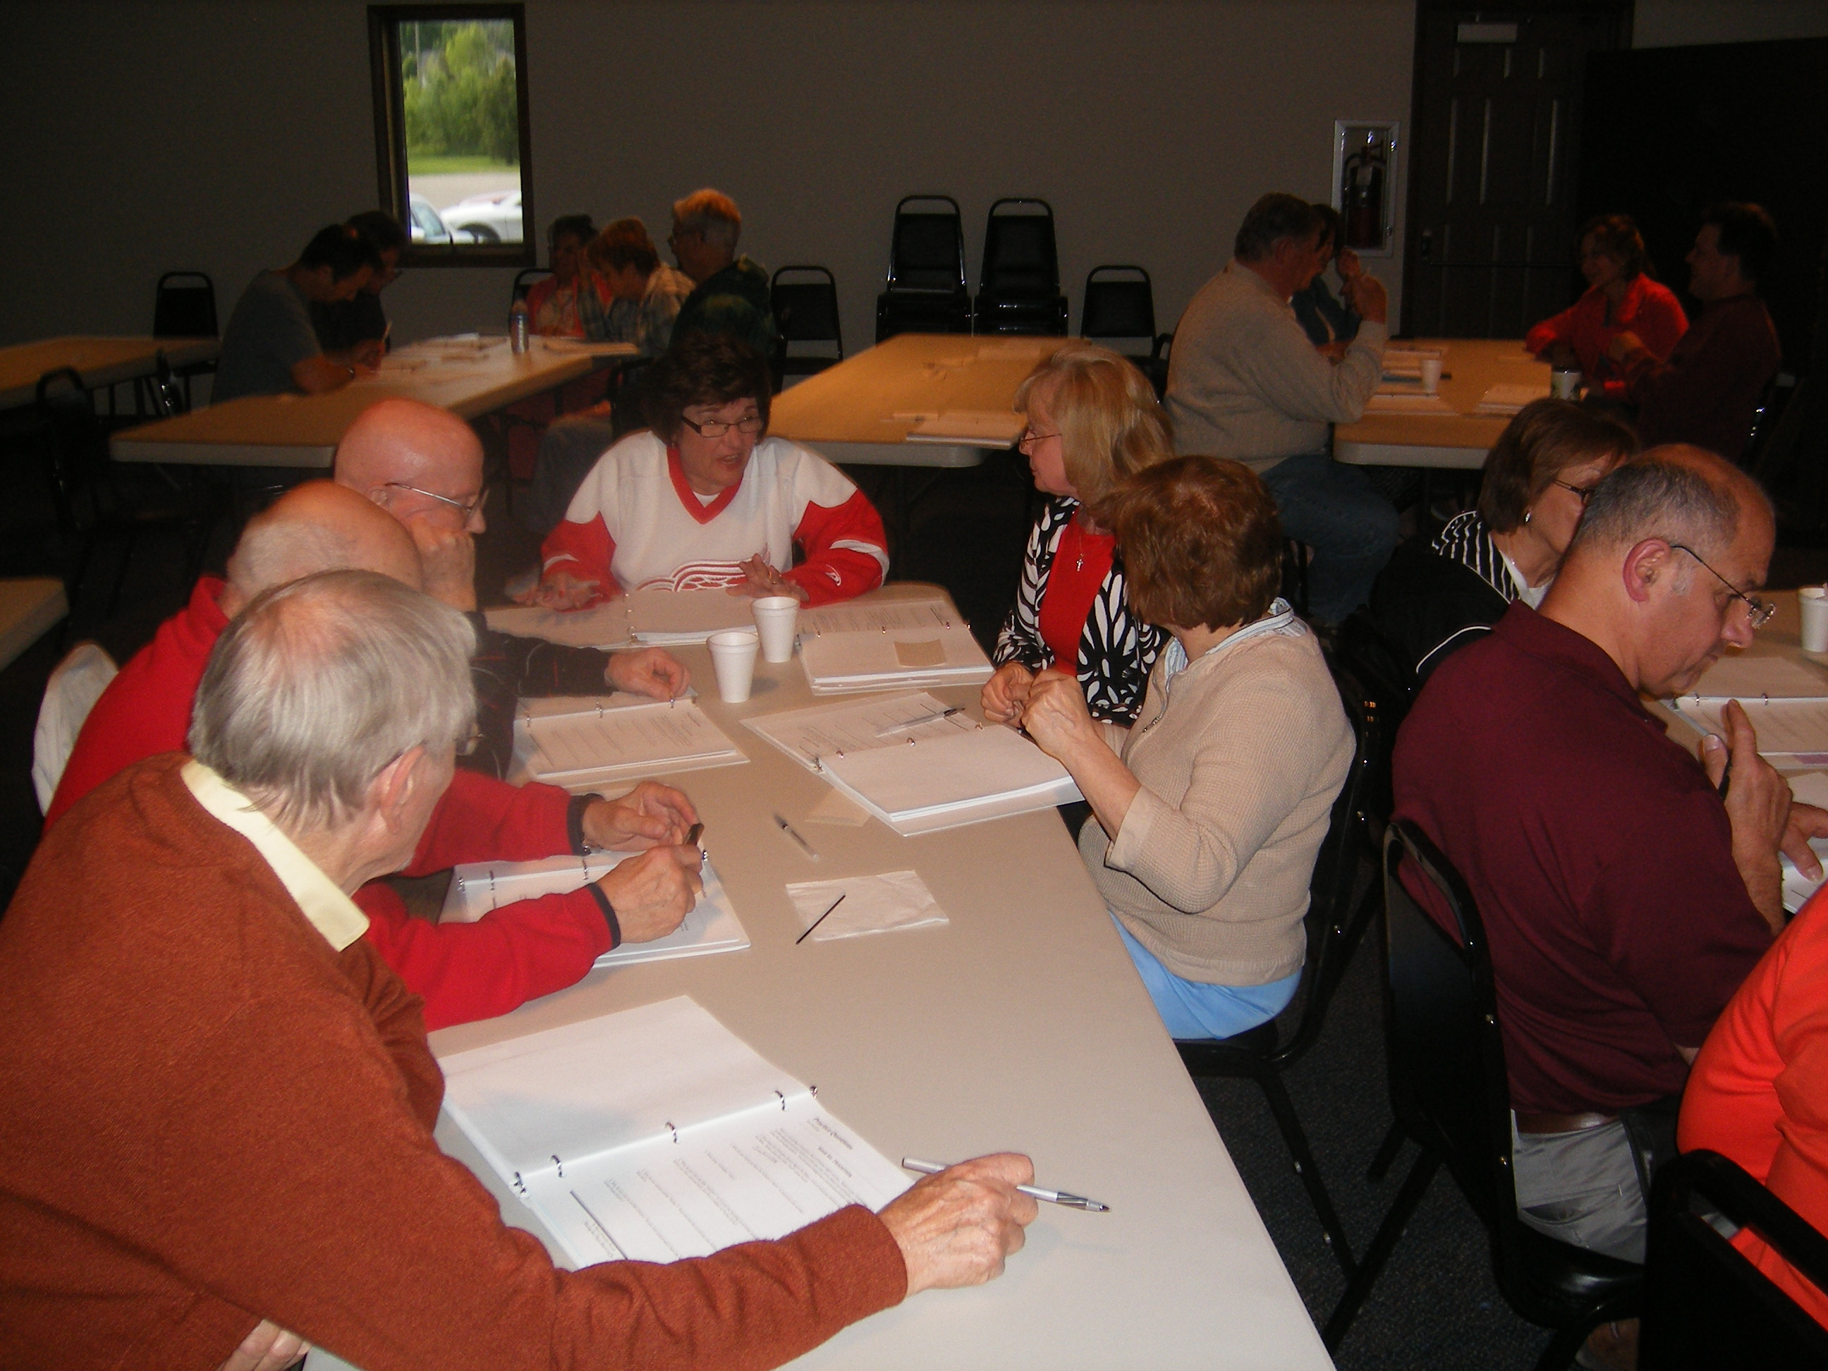
Adult Class

- Series of Orthodox Community Outreach Workshops on various topics with various speakers
- Liturgical Arts Workshop for Orthodox youth
- Capture Stories of Parish Heritage: A Multigenerational Parish Ministry to summarize important stories of your parish heritage and how it can inform your future – written and/or video.
- Small Group Ministry Pilot Project
- Orthodox Exposure - The Mission and Message of the Church: Mall Kiosk
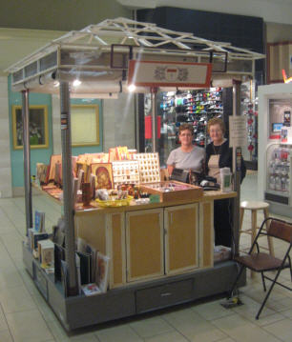
Mall Kiosk

- After school neighborhood ESL class or other. (homework assistance, reading, math component.)
- Development of a top notch whole parish stewardship education program.
- Conduct a series of leadership exercises designed to face forward. E.g. Develop a written Vision/Mission statement; complete the Parish Development inventory; small group discussion with parishioners (‘What are the important qualities we want to develop in our parish in the next 5 (or 10) years?’ ‘What do we value’? Do we live what we say we value?) Plan a long term (3yr.) budget. Survey parish neighbors. "Who are we?" “What do you know about us?”
- Education Project - Begin/ reinvigorate a Parish Adult education effort. Conduct a faith education audit. Identify key segments of parish population (seniors, parents, teens etc.) and determine what their formational status and needs really are. Offer something that fits one or more target groups.
- Bible study -- Perhaps in neighborhoods where parishioners live
- Establish a parish library or bookstore.
- Series of monastery pilgrimages – Plan a series of visits to monasteries.
- Sponsor a personal budgeting training class designed to help young families. Invite the neighbors.
"What not to do when guests arrive" video – create a humorous video identifying the wrong ways to welcome people to our parish. What are our growth limiting behaviors?
- Begin an active local charitable effort – one that involves a commitment of time from parishioners. (E.g Monthly effort @ Soup Kitchen)
- Sponsor a neighborhood block party.

