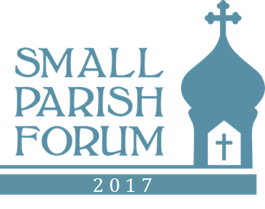
2017 Small Parish Forum Agenda
 | Thursday July 13
Tab | Approx. | Topic | Session leader
1 | 3:00 PM | Welcome& Introduction  Remarks from host hierarch; Forum goals; Agenda review; Theme intro | Joe Kormos
2 | 3:30 PM | Opening Talk – Small Parish Profile; Intro to Four Dimensions of Engagement | Fr. Justin Patterson
1 | 4:25 PM | Opening Workshop(s)  Pros/ Cons of Small Parishes Attendee Profile & Intros Target Outcomes | Kormos
 | 5:15 PM | Vespers | Fr N Breckenridge
 | 5:45 PM | Dinner | All
3 | 6:35 PM | Workshop: Principles of Vibrant Small Orthodox Parishes | Kormos; staff; small groups
 | ~7:45 | Adjourn – whenever energy is waning.
 | Friday July 14
 | 8:45 AM | Trisagion Prayers with Epistle and Gospel | Fr. Breckenridge
2 | 9:00 AM | Engaging in Change – Small Parish Profile  Christ the Savior Rockford IL (ACROD – (video) | Fr. Bannon
4 | 9:25 | Engaging in Worship Role of the Small Parish Choir | Mother Seraphima
 | 10:15 | Short break
5 | 10:30 | Engaging with Our Neighbors  Multiple brief presentations about reaching out to others; QA and small group workshop. | Matt McCroskery; Janet Damian; Frs. Carpenter; Proctor
 | 12:00 | Group Photo | In Church
 | 12:05 | Lunch | All
2 | 1:00 | Engaging in Change -- Small Parish Profile Holy Ascension Albion MI | Fr. Joshua Frigerio
6 | 1:30 | Engaging Across Generations  Lasting, authentic community. Presentation & workshop | Fr. Marc Vranes & Cathy Vrugitz
 | 2:45 PM | Break
 | 3:00 | Communicating Your Parish -- or TBD -- or catch up
 | 3:55 | Break
4 | 4:15 PM | Workshop: Engaging in Worship  Practical Singing Solutions for Small Parishes | Mother Seraphima
 | 5:15 PM | Vespers | Fr. Breckenridge
 | 5:45 PM | Dinner
 | 6:30 PM | Adjourn
 | 7:45 PM | Reception @ Spring Hill Suites Hotel: Pittsburgh Mills; beer, wine, snacks, cheese… beer | All
 | Saturday July 15
 | 9:00 | Trisagion Prayers with Epistle and Gospel | Fr. Breckenridge
 | 9:15 | Open Issues from previous sessions | Kormos
7 | 9:30 | Engaging with Our Future: Mission, Values, Identity | Fr Baktis/Kormos
 | 10:25 | Break
 | 10:40 AM | Engaging with Our Future (cont’d) | Fr Baktis/Kormos
8 | 11:30 | Closing Session  Update Principles of Healthy Small Parishes  Select from pre-defined action projects list– begin planning | Kormos
 | 12:15 | Adjourn/box lunch

